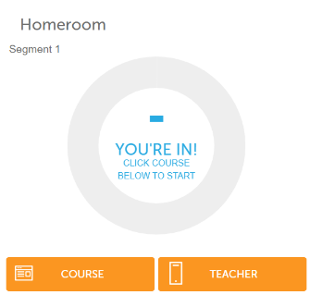
- Go to your courses through the FLVS icon in Classlink (see below)
and then click “course” (see image to the right)
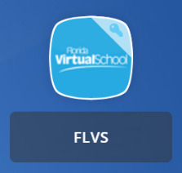

- Once in the course, select “Tools” along the top ribbon of the page.
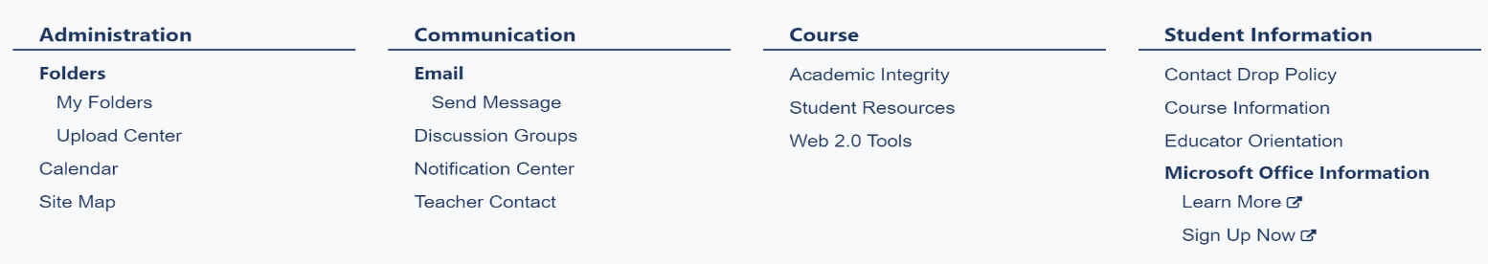
- Next, click on “Course Information” found under “Student Information” to the right of the screen.
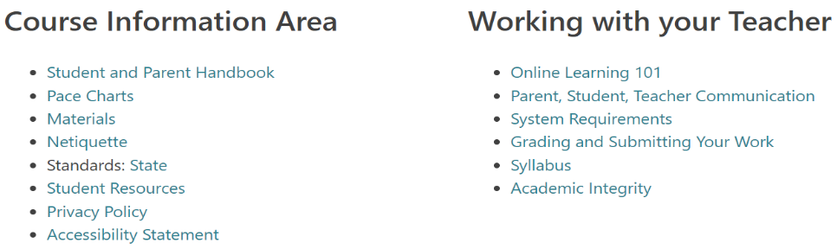
- On the Course Information screen select “Pace Charts” or “Pace” which can be found under “Course Information” (note that this screen can look slightly different for each subject area)

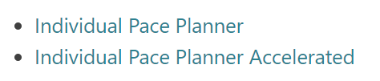
- Scroll down on this page and you will see “Individual Pace Planner” select “Individual Pace Planner” (note that students wanting to complete the Honors/Accelerated version of the course will want to select the correct option)

- Once in the planner, input the listed information to generate and print your Pace Planner
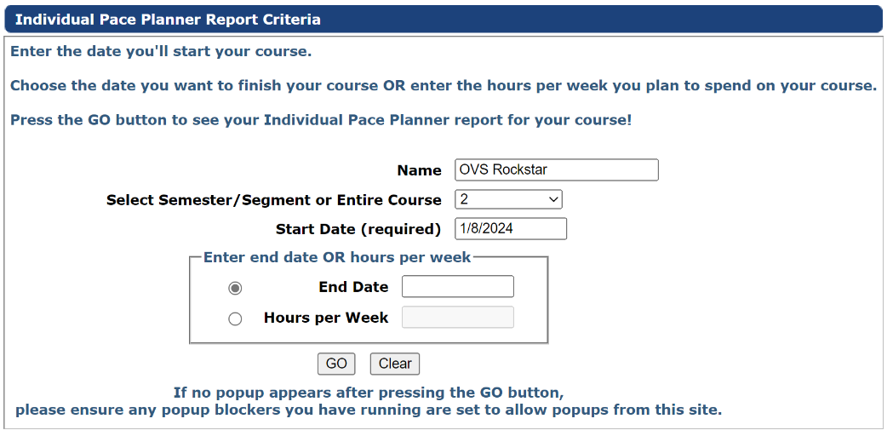
Name: (Your Name)
Select Semester: 2
Start Date: Jan 8, 2024
End Date:
Seniors May 12, 2024
All OthersMay 19, 2024

Click “GO”

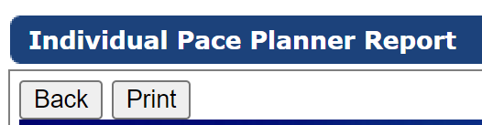
- A new screen will open with your pace planner. Click “PRINT” in the top left.

